PATIENT DATA ANALYSIS USING KNIME
Health Care Data Analytics Project
DILKUSH M

PROJECT INTRODUCTION AND PROBLEM STATEMENT:
The Healthcare System project simulates patient data to generate insights for hospital management. It uses three datasets Patient Profile, Treatment Records, and Visit/Follow-ups. The project identifies patients at risk, analyses treatment outcomes, and studies the impact of follow-up compliance on recovery. This helps demonstrate how data analysis can improve healthcare decisions and patient care.

PROJECT OBJECTIVES:
The primary objectives are to perform fundamental data manipulation tasks on the hospital datasets to facilitate data-driven decision making. The core tasks include:
- Filtering to identify specific patient segments (e.g. patients who missed follow-up visits, whose treatment outcomes are poor, filtering by age group etc).
- Grouping and Aggregation to calculate key metrics, such as average recovery rate, compare treatment outcomes etc.
- Joining multiple related tables using the common key Patient ID for easier analysis

DATA DESCRIPTION AND SIMULATION:
This project uses three related datasets, connected through a common key Patient ID. These datasets together provide a complete view of patient health, treatment progress, and follow-up compliance.
- Patient Profile Dataset:
Contains core demographic and medical details of each patient, including Patient ID, Name, Age, Gender, Diagnosis This dataset forms the foundation for identifying and categorizing patients based on their health conditions.
- Treatment Dataset:
This dataset stores detailed information about the treatments provided to each patient.
It includes attributes like Patient ID, Treatment Procedure, Outcome, Start Date
It helps analyse how different treatments are administered and their impact on patient recovery.
- Follow-up Dataset:
This dataset records the follow-up and visit details of patients after treatment.
It contains Patient ID, Visit Date, Doctor , Follow-up Status
It is used to track whether patients attend their scheduled follow-ups and which doctor they visited

KNIME WORKFLOW :

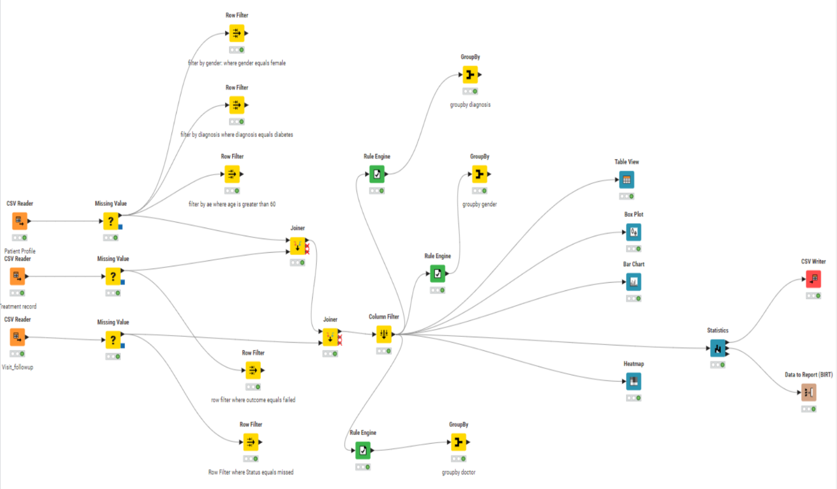

WORKFLOW AND METHODOLOGY:
The project requires simulating or importing the hospital datasets.
KNIME NODE | PURPOSE | INPUT/ CONFIGURATION | EXPECTED OUTPUT
Table Creator | Table Creator (x3)² | To manually simulate the three required datasets: patient profiles, treatment records,  Visit follow-up | Configure schema and enter sample data for each dataset3.Three separate table containing the simulated data columns
Table Creator | CSV Creator or CSV Reader | Alternative for generating or importing larger, more realistic datasets. | Point to a local CSV file or configure data generation parameters. One or more output data tables ready for processing.

OUTPUT:
Table: patient profile
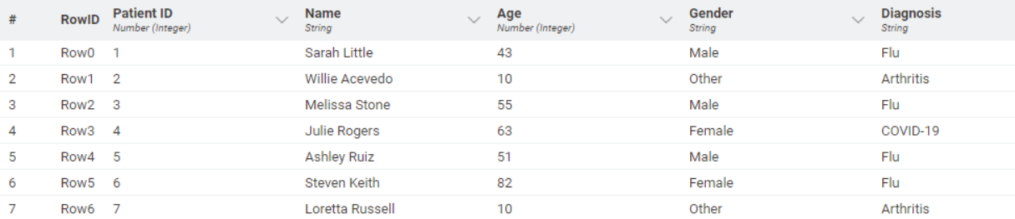
Table: Treatment records
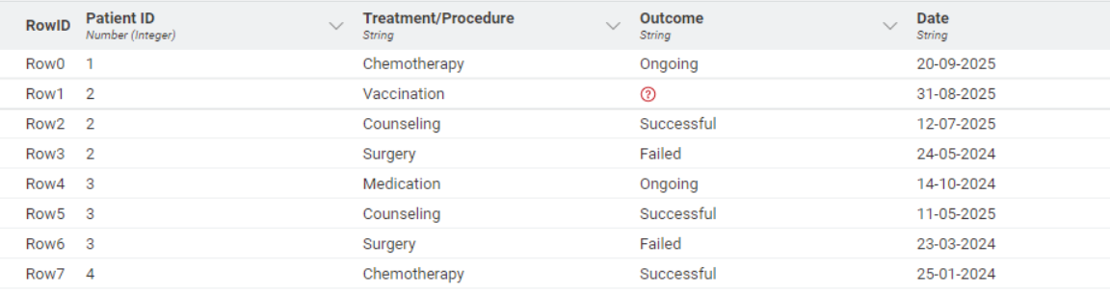
Table: Visit followup
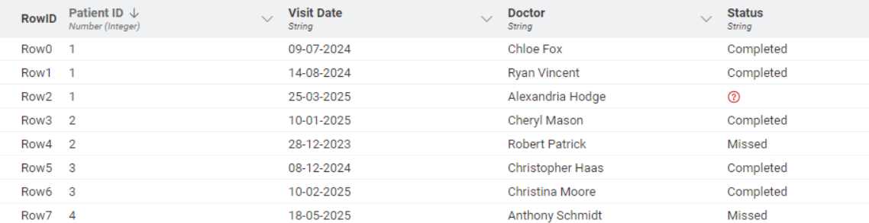

FIRST CHECKS AND PRE-PROCESSING:
Handle missing values using the Missing Value node.
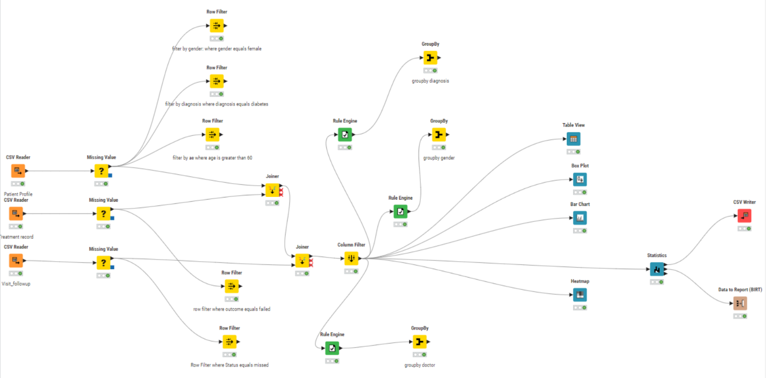
After applying the missing values node on all the three datasets the missing values of the data will get updated
Updated table : patient profile
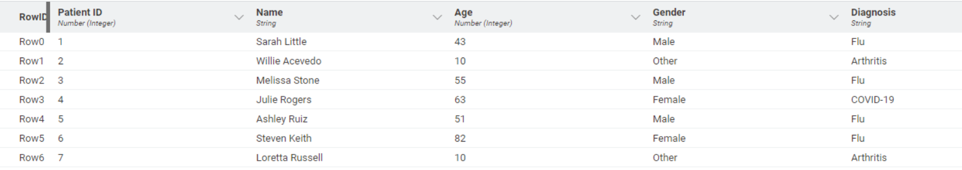
Updated table: treatment record
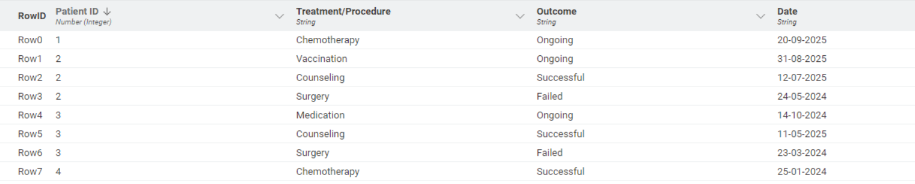
Updated table: Visit followup
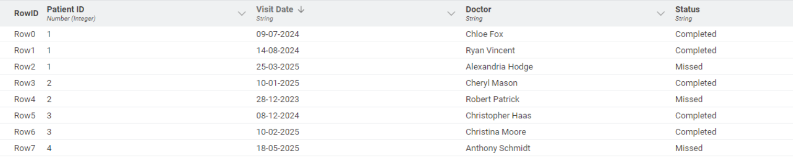
FILTERING TASK :
This stage ensures data quality and proper data types.
KNIME NODE | PURPOSE | INPUT/  CONFIGURATION | EXPECTED OUTPUT
Row Filter | Row Filter | Remove/filters out rows that contain invalid or clearly erroneous data points | A table containing only valid and clean records

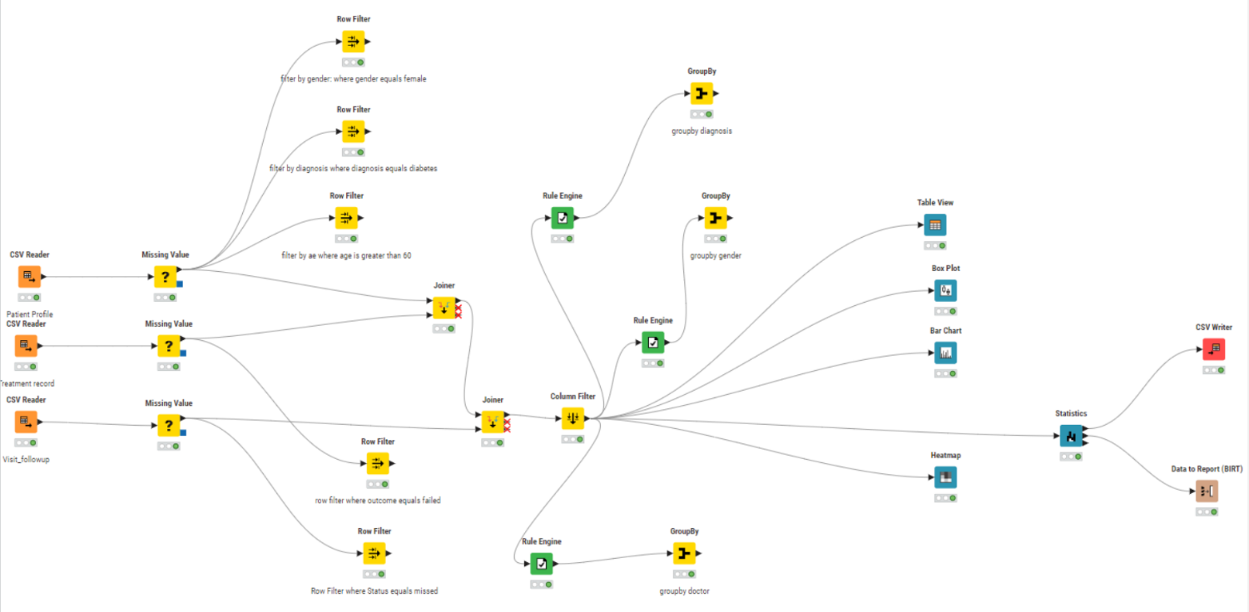
OUTPUT:
Row Filter : Gender = 'Female'
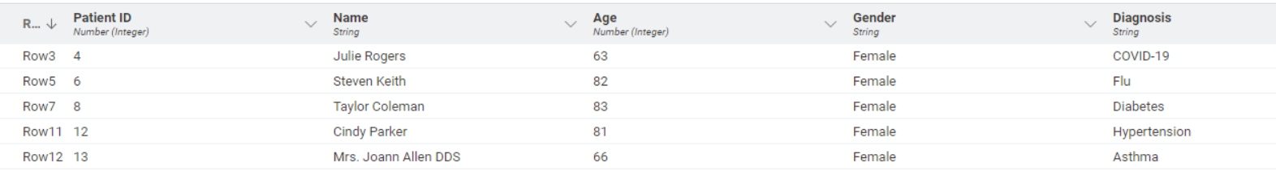

Row Filter : Diagnosis = 'Diabetes'
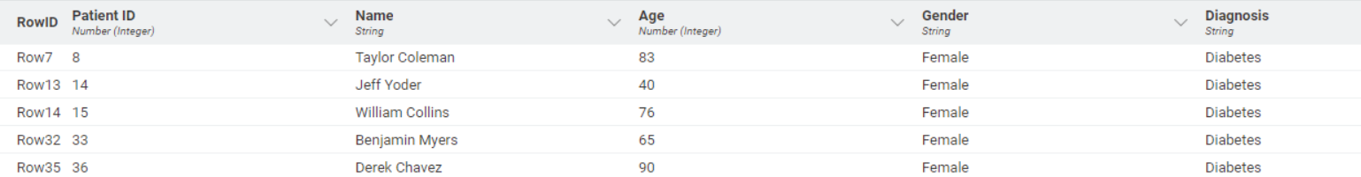

Row Filter : Age greater than 60
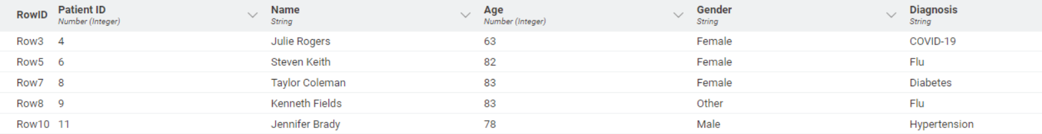

Row Filter : Outcome = 'failed'
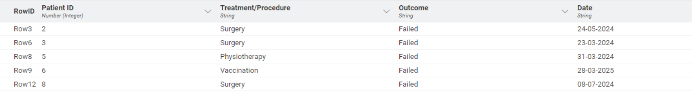

Row Filter : Status = 'Missed'
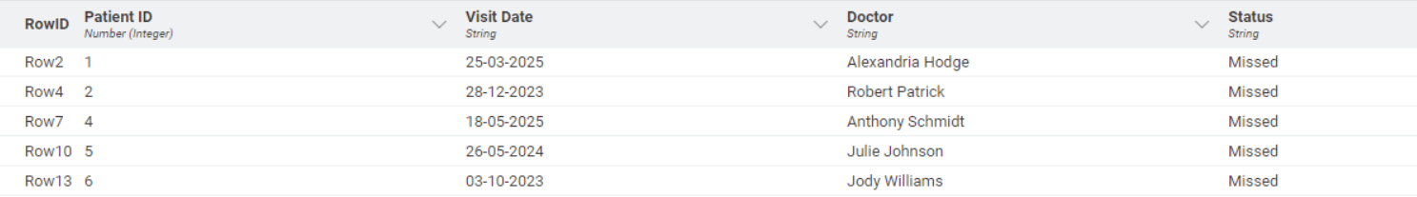
JOINING DATASETS :
The join operation links the separate employee records based on patient ID.
KNIME NODE | PURPOSE | INPUT/  CONFIGURATION | EXPECTED OUTPUT
Joiner | Joiner | Input 1:  Patient profile;  Input 2:  Treatment record  After joining these two tables join it with visit followup table | A common table joined on patient id

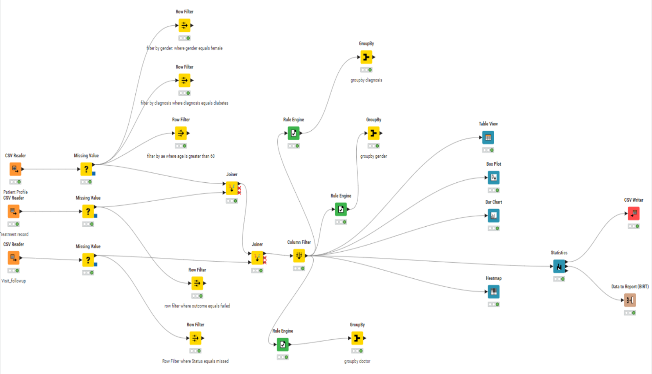

OUTPUT:
Joining all three tables into a single table using joiner on patient id
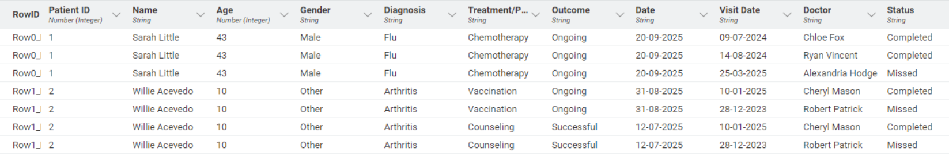
GROUPING AND AGGREGATION :
The GroupBy node is used to summarize the data and calculate average metrics by various categories.
KNIME NODE | PURPOSE | INPUT/  CONFIGURATION | EXPECTED OUTPUT
Groupby | Groupby | Calculate average recovery rates by diagnosis | A small summary table having columns diagnosis and mean(prediction) recovery rates
Groupby | Groupby | Calculate treatment success rate by doctor | A small summary table having columns gender and their recovery rates mean(prediction)
Groupby | Groupby | Comparitive analysis by gender | A small recovery table having columns doctor and treatment recovery rates mean(prediction)

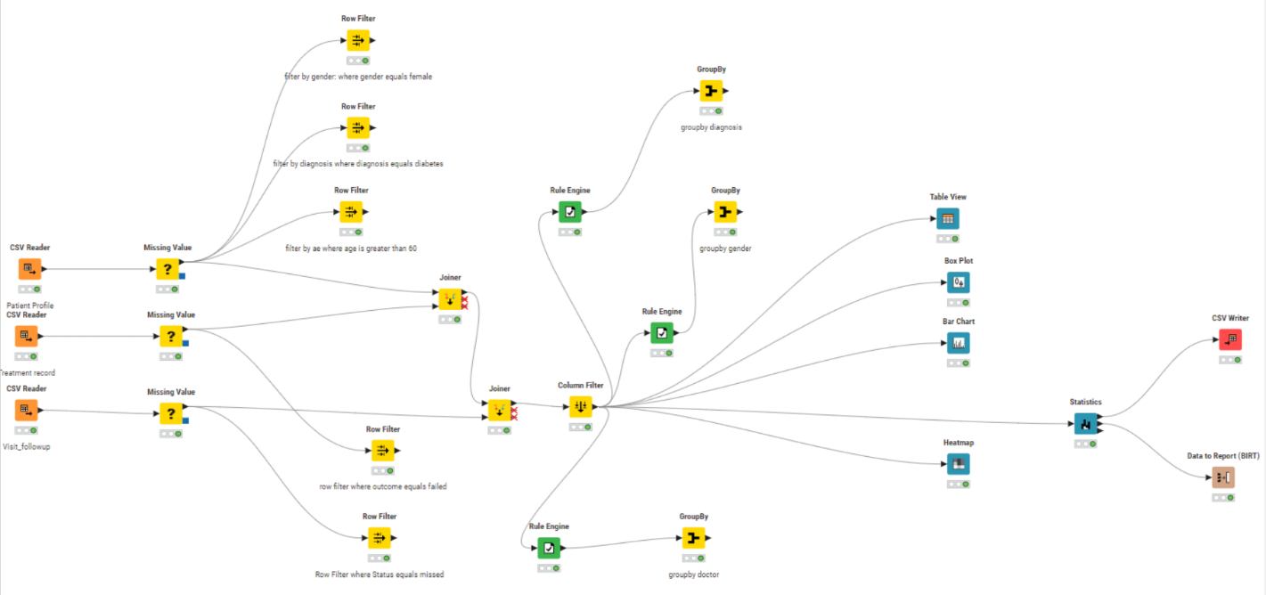
OUTPUT:
Since the recovery rate is a categorical value we used rule engine node to convert it into numerical (recovered = 1 else = 0) after that we found the mean of that value.

GroupBy : Avg recovery rate by diagnosis
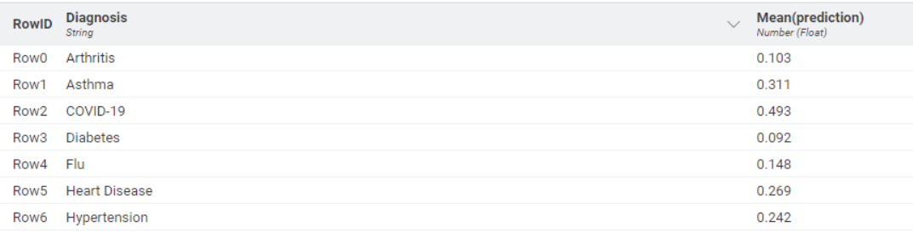

GroupBy : Avg recovery rate by gender
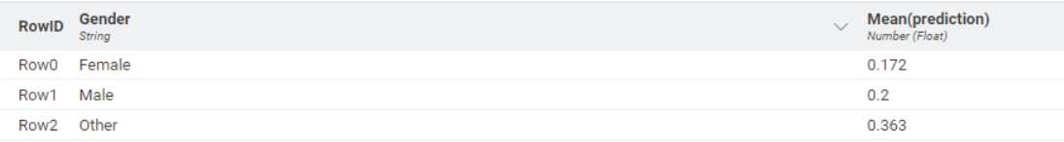

GroupBy : Avg recovery rate by Doctor
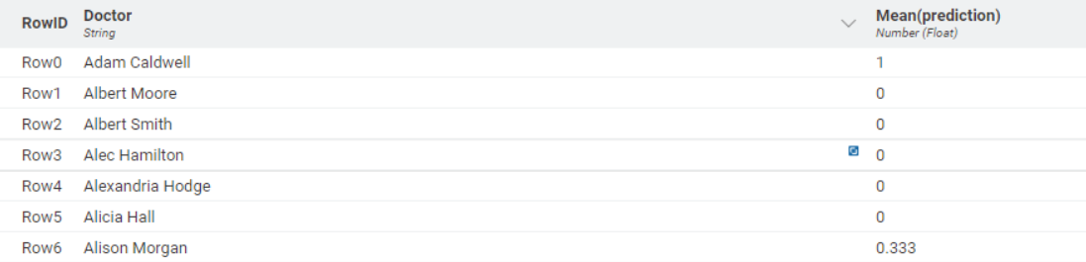

EXPLORATION AND REPORTING :
The final stage involves visualizing and exporting the results.
KNIME NODE | PURPOSE | INPUT/  CONFIGURATION | EXPECTED OUTPUT
Bar chart | Plot a Bar chart | Treatment procedure and concurrent count | Bar chart is plotted
Box plot | Plot a Box plot | Age and gender | Box plot is plotted
Heat map | Plot a Heat map | Diagnosis and outcome | Heat map is plotted
Table view | View in table form | The merged dataset | Table is created

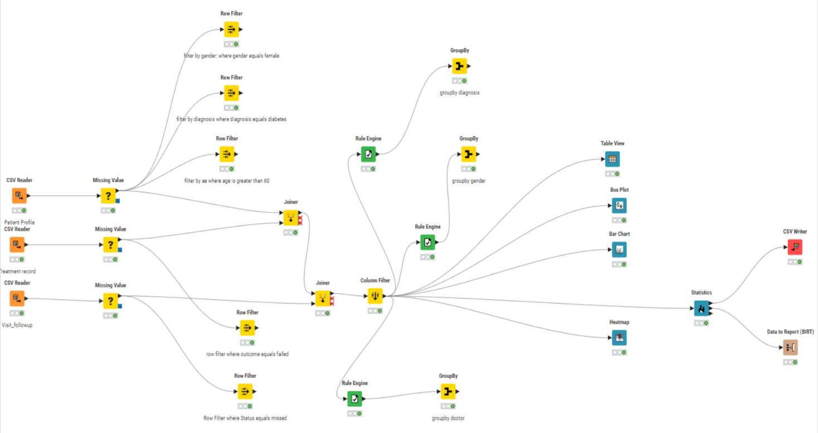

OUTPUT:
Table view
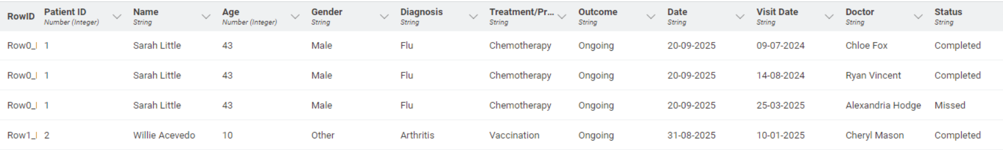
Bar chart
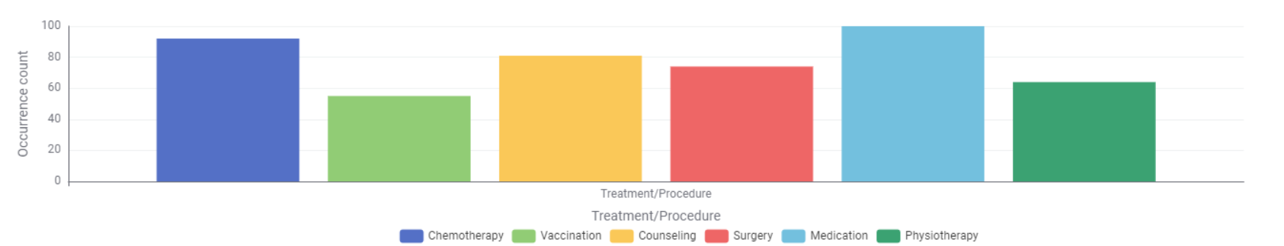
Box plot
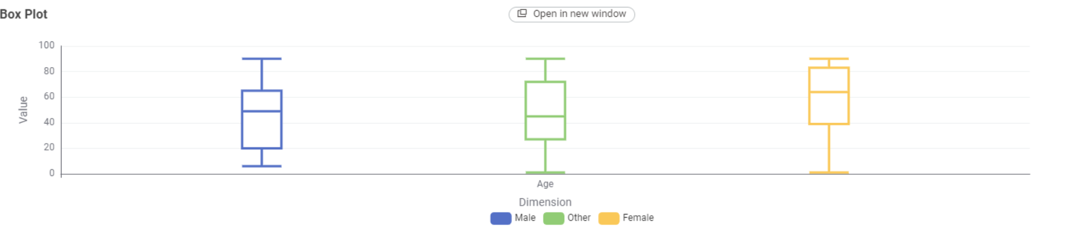
Heat map
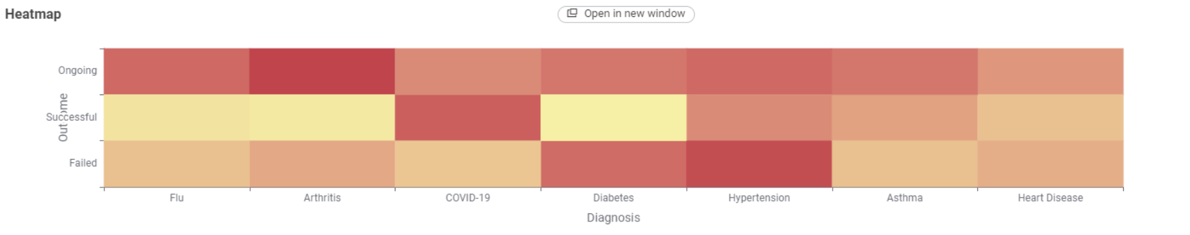

WRITING THE DATA AND MAKING SUMMARY
Use excel writer/CSV writer to save the final output and summary table
Merged table:
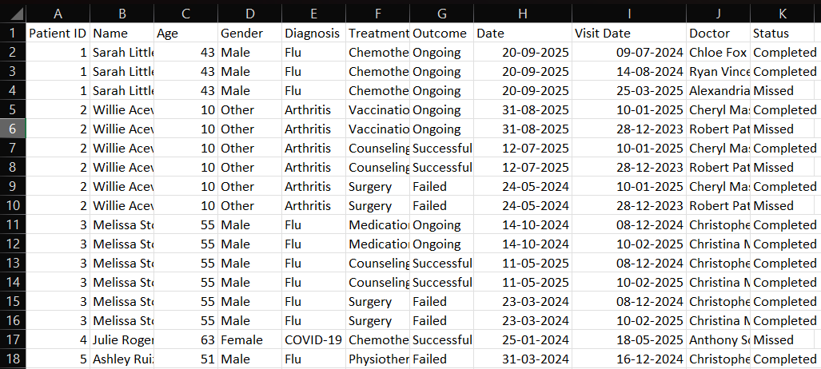

Summary table:

TARGET INSIGHTS AND BUSINESS QUESTIONS :
The data manipulation workflow is designed to answer key business questions and generate actionable insights:
- How can hospitals improve patient recovery outcomes through data-driven monitoring?
- By analysing treatment success rates and follow-up compliance, hospital management can identify which patient segments (e.g., age group, diagnosis type, or doctor) require more attention or different treatment strategies.
- Which doctors and departments demonstrate the highest treatment efficiency and patient satisfaction?
- Measuring and comparing success rates by doctor and diagnosis helps management allocate resources, recognize high-performing staff, and identify where additional training or support may be needed.
- Can predictive insights reduce missed follow-up visits and prevent patient dropouts?
- By tracking patterns in missed appointments and linking them with treatment outcomes, the hospital can develop targeted reminders or engagement strategies to ensure better patient adherence and overall care quality.

CONCLUSION:
This project demonstrates how data analytics can play a crucial role in improving healthcare management. By integrating and analyzing patient, treatment, and follow-up data using KNIME, meaningful insights such as recovery trends, doctor performance, and patient compliance were uncovered. These insights highlight the potential of data-driven decision-making in enhancing hospital efficiency, optimizing treatment plans, and improving overall patient outcomes.

